ONE PAGER TEMPLATE
Topic Name

Answer the following questions …..

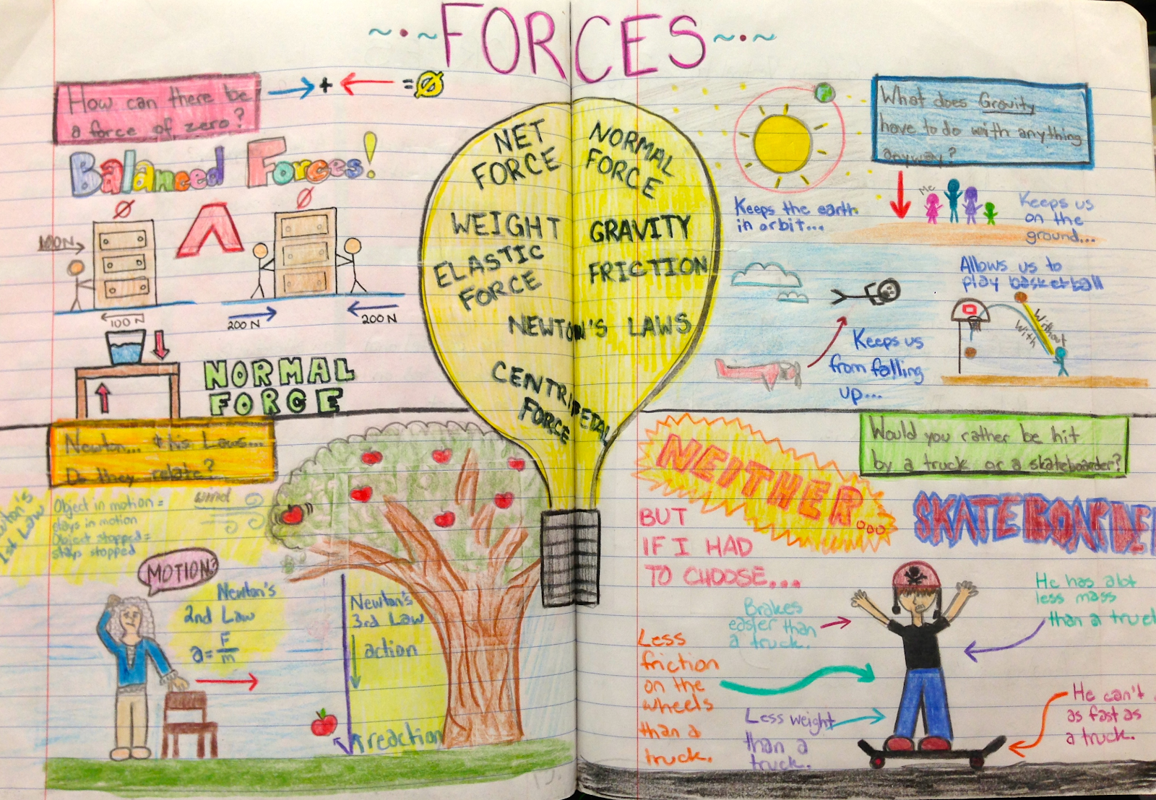
One Pager Directions
CLICK HERE FOR SCIENCE ONE PAGER EXAMPLES

………….. to create a one pager in your science notebook that addresses the following:

CONTENT REQUIREMENTS

- Include the title -
- …
- …
- …
- ….
- Include at least three “real world” connections to the topic.

Visual Requirements:
- Use at least five colors
- Each vocabulary term should have at least one image connected to it
- Be creative
- Embrace stick figures
- Have Fun
- Create cartoons

