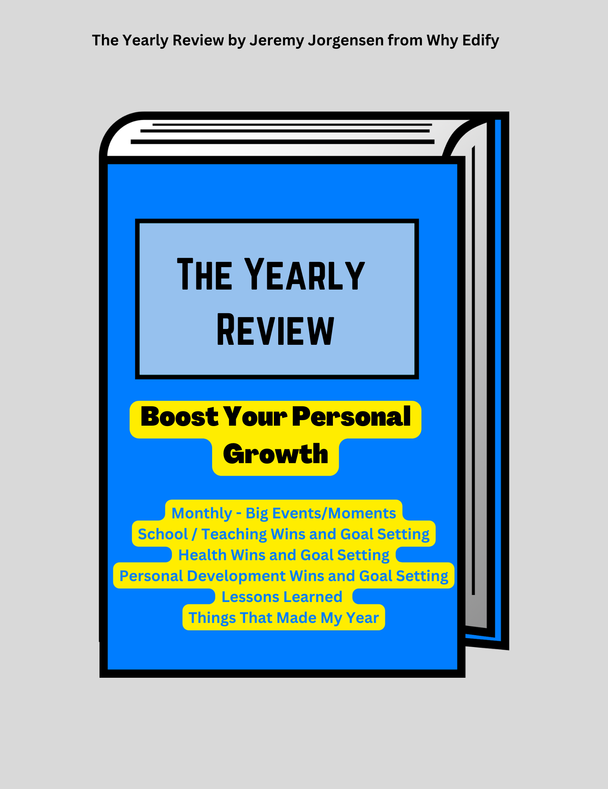
Welcome to Why Edify The Yearly Review

Thank you for downloading The Why Edify Yearly Review.

The Yearly Review is a simple exercise that will boost your personal growth. Taking two or three weeks at the end of the year to reflect on your wins (in and out of the classroom) and accomplishments will help you identify what went well and set you up to set goals for the upcoming year.

You have access to the PDF and Microsoft Word version of The Yearly Review so you can reflect using paper and pen or with your keyboard. Also, feel free to add your own sections to make this review work best for you.

The Yearly Review consists of the following parts:

  - Monthly - Big Events/Moments
  - School / Teaching Wins and Goal Setting
  - Health Wins and Goal Setting
  - Personal Development Wins and Goal Setting
  - Lessons Learned
  - Things That Made My Year

Credit and Thank-You

The following authors have inspired me to complete a yearly review. I'm appreciative for their ideas and inspiration.

  - James Clear: Annual Review
  - David Perell: Annual Review
  - Matthew Dicks: Resolutions and Monthly Goals

Big Events / Moments - These are the big things that happened that tell the story of your year.

January

1.

2.

3.

4.

5.

February

1.

2.

3.

4.

5.

March

1.

2.

3.

4.

5.

April

1.

2.

3.

4.

5.

May

1.

2.

3.

4.

5.

June

1.

2.

3.

4.

5.

July

1.

2.

3.

4.

5.

August

1.

2.

3.

4.

5.

September

1.

2.

3.

4.

5.

October

1.

2.

3.

4.

5.

November

1.

2.

3.

4.

5.

December

1.

2.

3.

4.

5.

Personal Development Wins and Goal Setting
Here's your place to list what went right and to set some goals for next year. What habits did you develop? What were your successed in character development?

Wins

1.

2.

3.

4.

5.

6.

Goals

1.

2.

3.

4.

5.

6.

Teaching Wins and Goal Setting
Here's your place to list what went right during the school year. What did you try that worked out well? What kinds of professional development did you complete?

Wins

1.

2.

3.

4.

5.

6.

Goals

1.

2.

3.

4.

5.

6.

Health Wins and Goal Setting
Here's your place to list what went right and to set some goals for next year. Did you set and achieve any diet or fitness goals. Did you track your activity? Maybe you ramped up your self-care routine.

Wins

1.

2.

3.

4.

5.

6.

Goals

1.

2.

3.

4.

5.

6.

What Lessons Did You Learn?

1.

2.

3.

4.

5.

6.

7.

8.

9.

10.

Things That Made My Year
Have fun with this one. Think of your favorite songs, shows, movies, books, sporting events, etc. from the year.

1.

2.

3.

4.

5.

6.

7.

8.

9.

10.

MAY EACH YEAR BE BETTER THAN THE ONE BEFORE IT!

