Notebook Reflections Ideas/Examples (for notebook creative reflections) - Use Color and Creativity
Your reflections should be colorful, creative, and neat. The work you do should focus on the learning targets, science vocabulary, and science ideas. When you are finished your work should provide evidence of your understanding.

- Pictures/Drawings
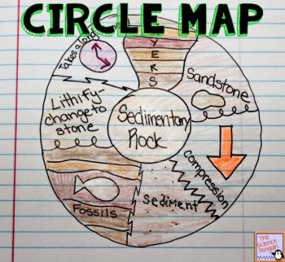

- Mind Mapping
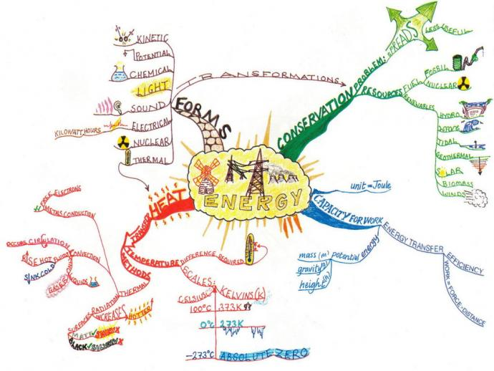

- Four Square Vocabulary Diagram
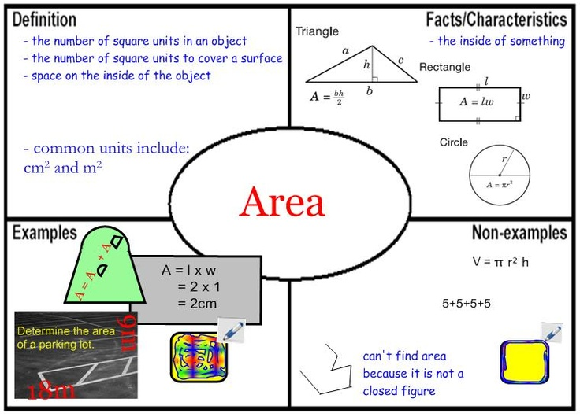

- K.I.M. Vocabulary Strategy
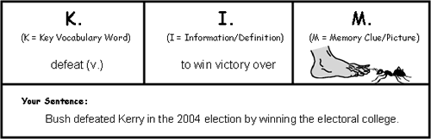
- Written Reflections
- Poem
- Song/Rap
- Haiku
- Riddle
- Four Hashtags ####
- One Sentence Summary
- Cartoon
- Acronym
- Write 4 “What if……” statements about the topic
- How does this topic relate to your life?
- What’s the best way to remember this
- topic?
- Summarize what you learned.
- Make Connections
  - to text
  - to self
  - to world
  - movie
- Pictowords
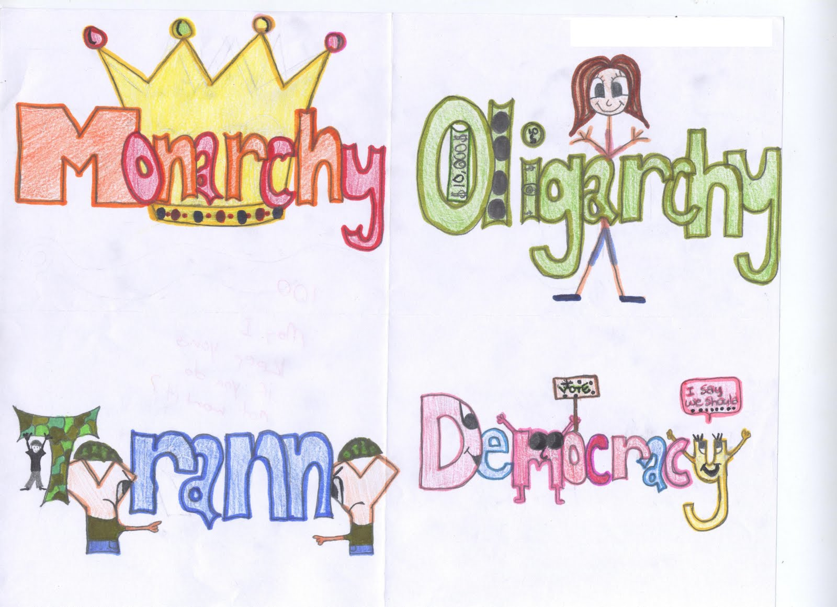

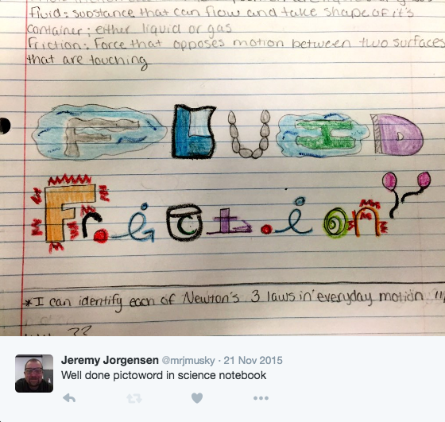

- Learning Target Illustration
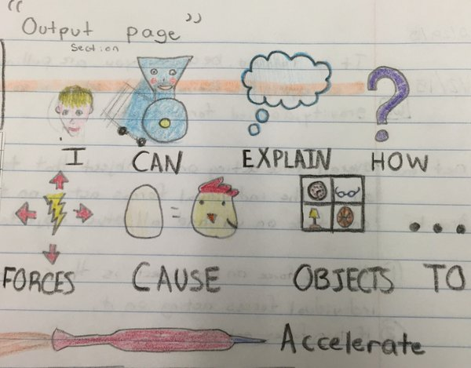

Interactive Science Notebook
CREATIVE REFLECTIONS
Draw and Label a Diagram  - Review your notes on the right side.  - Draw a diagram that represents the concept. (Make sure it explains the essential question.)  - Include any labels that are required.  - Write 5-6 complete sentences that explain the concept illustrated in the diagram.  Requirements  - Diagram is neat and legible.  - Drawing is in color.  - Diagram and labels are accurate.  - 5-6 complete sentences are used to describe the concept in the diagram. | 3-2-1 Summary  All 6 statements and questions should be in complete sentences.  Write 3 facts that are new to you.  Write 2 things you found interesting.  Write 1 question that you are still wondering OR that can be answered with the other 5 facts.  Be sure to add a title.  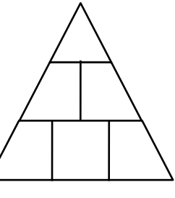  Example: When reading about a biome, find 3 new facts, 2 interesting facts, and ask 1 question.  You can draw a pyramid like this for your  3-2-1.  Idea from Marionschools.net
T-Shirt Ad  - Review your notes on the right side.  - Identify key vocabulary and concepts.  - Front of t-shirt has a picture of the concept.  - Back of T-shirt has 1-2 sentences covering a key concept.  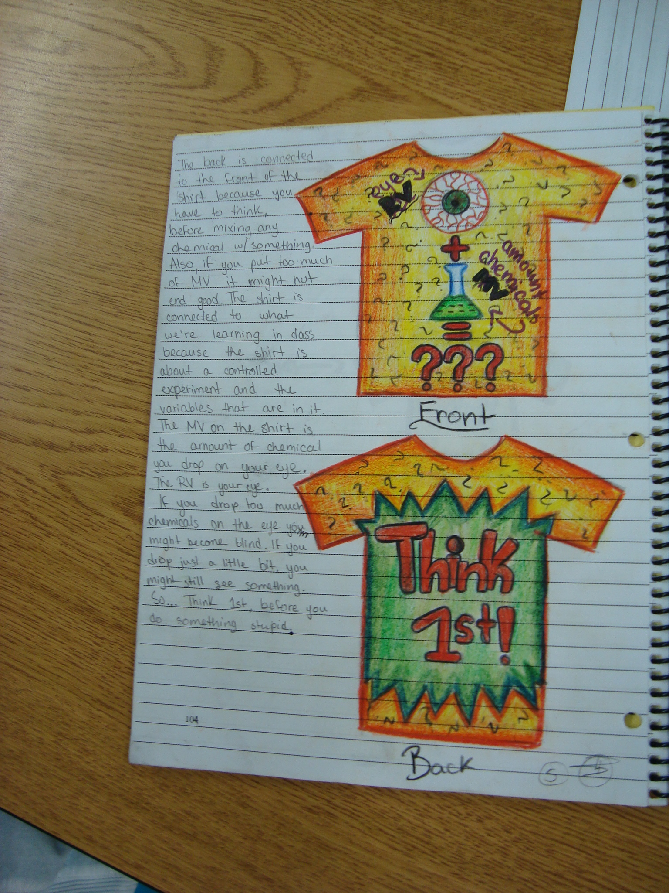  - On the sidebar, write 1-2 paragraphs about the concept.  Requirements  - T-shirt drawing and writing is neat and legible.  - Drawing contains a front and back t-shirt design.  - Drawing is in color.  - 1-2 paragraphs about the concept is accurate. | Magazine Cover  Look at some classroom magazines to get ideas.  Requirements  - Create and draw a magazine cover that is attractive and colorful!!!  - You must include the topic.  - You must include 4 extra headlines that highlight a story in the magazine.  - Be sure to add a title.  - Example: Draw a magazine cover that would be about stars.  Challenge: Write an article that would be included in the magazine.  Idea from Marionschools.net
Cartoon  Requirements  Cartoon  - Single Frame cartoon (like a Farside)  - 4 colors minimum (Black and White DO NOT COUNT)  - Maximum 2 lines for a caption (speaking bubbles are okay, but not encouraged)  Cartoon Explanation  - The science concept being shown is stated  - A paragraph explaining why or how the cartoon shows or addresses the concept stated is written | Write a Letter to A friend  Requirements  Letter  - Include a salutation, ex. Dear Maria,  - Explain the concept we are studying  - Include key vocabulary  - Explain any misconceptions  - Diagram  - Closing, ex. Sincerely, Mohammad
Fabulous Fold-Ups!  Concept maps demonstrate relationships between ideas. They help you understand concepts by clarifying ideas and terms, and by dividing complex concepts or  processes into smaller parts. You can use concept maps to relate, define, brainstorm, and sequence.  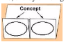  Instructions for a Concept Map Fold-Up:  1. Fold a sheet of paper along the long or short axis, leaving a two-inch tab uncovered.  2. Fold in half or in thirds. (Additional tabs can be created by folding into more parts.)  3. Unfold and cut along the inside fold lines to create tabs.  4. Have students identify the concept by writing key words or using pictures on the two-inch tab. Draw arrows from the central idea to the tabs, where students  record data underneath each tab.  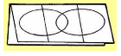  Instructions for a Venn Diagram Fold-Up:  1. Fold a sheet of paper in half like a hotdog.  2. With the paper horizontal, fold the right edge toward the center, trying to cover one half of the paper.  3. Fold the left side over the right and crease to form three tabs.  4. Draw two overlapping ovals on the front.  5. Cut up the two valleys on one side only.  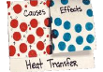  Instructions for a Focus Skills Fold-Up (Cause and Effect):  1. Fold a sheet of paper in half horizontally (hamburger) so that one side is one inch longer than the other side.  2. Cut the shorter side in half, up towards the fold (mountain top) to create two flaps. | Write a Quiz  - Review your notes on the right side.  - Write a 5 question quiz.  - The types of questions may include multiple choice, short answer, or matching. You must include at least ONE short answer question that has at least a 3-5 sentence explanation.  - Write the answer key. Include the answers in a flip tab or fold out.  Requirements  - 5 questions are written that reflect the concepts studied.  - Questions and answers are neat and legible.  - Answer key is provided and correct.  Other Ideas  Advertisement Awards Bedtime Story Billboard Board Game Brainstorming Brochure Bumper Sticker Cereal Box Cover Character Chart Children's Book Comic Strip Compare/Contrast Crossword Puzzle Fables Flow Charts News with Headlines Graphs Greeting Card Interview Invitation Jokes KWL Nursery Rhyme Organizers Persuasive Essay Poetry Postcards Questions Riddles Song/Rap Sports Stories Story Board Summaries Thank You Note Wanted Poster

Creative Reflections:
Brainstorming
Concept Maps
Graphic Organizers
Questions you have about the topic (Things you are confused about or questions that extend beyond the core material)
Describe the event in your own words with pictures
“Wanted” posters (for famous people)
Write a eulogy (for famous people)
Flow Charts, Sequence Charts
Compare/Contrast Chart
Venn Diagram
KWL Chart
Create a political cartoon
Comic Strip/graphic novel story
What ifs… (we chose not to drop the bomb, Huns never invaded Rome, etc.)
Poems, Songs, Raps, Limericks
Write a Riddle
Create a Story about topic
Charts, Graphs, Tables
Mnemonic Devices
What do you already know about topic?
Create and label/annotate a visual illustration (drawing) explaining the topic
How does this topic relate to your life?
What are the important details to remember?
Current events/articles that relate to topic
Write a newspaper article about the topic
Write a letter to a past historical person
Outcome Sentences:
I learned…, I was surprised to find…, This reminds me of…, I wonder what would happen if…, I now understand…, because…, I liked…, I didn’t like…, The important thing about…
Say it in a Sentence (summarize the entire lesson in one sentence)
Here I Stand (tell me how you feel personally about this topic)
Diary entry as a person from the time

